Construction Group
Project Manager: Crushelle Triplett
Mentor Manager: Jack Cadman
Team Members: Jesse Mills / Jamie Kim / Leslie Sadkowski / Luis Cabrera

01.19.2017 Meeting
Milestone: By the end of this meeting you should understand and have presentation material showing:
- Identification of existing materials in St. Boniface Church
- Identification of location/quantity for material repairs / replacement
- Identification of building elements to be demolished due to poor / unstable condition
- Unit Costs of replacement materials / preliminary total cost for replacement materials
Client Requests / Comments:
- Compare costs for replacement of materials with traditional v. contemporary substitute alternatives. (Ex. Substitute cast stone for carved stone) Where can we save money?

------------------------------------------------------------------------------------------------------------------------------------------------------------

01.26-2017 Meeting
Milestone: By the end of this meeting you should understand and have presentation material showing:
  - Assemble a list of St. Boniface exterior preservation items and their costs. Some items are easy to estimate (brick should be tuck-pointed). Some items require additional coordination (which windows do the old building group want to preserve?). Coordinate alternate materials which might have a large cost savings.
  - Identify project items which might have long lead-times and might be important for schedule.
  - Begin to coordinate structural requirements/materials for the new and old buildings.
  - Understanding of types of permits we might need, how much they might cost, and how much time we should reserve to obtain them.
Client Requests / Comments:
- I’m nervous about how long the renovation of the existing church will take. Please begin to assemble a preliminary pull schedule to show how long the preservation of St. Boniface Church will take. Please update it with information over the next 3 weeks, I’d like to see an estimate then.

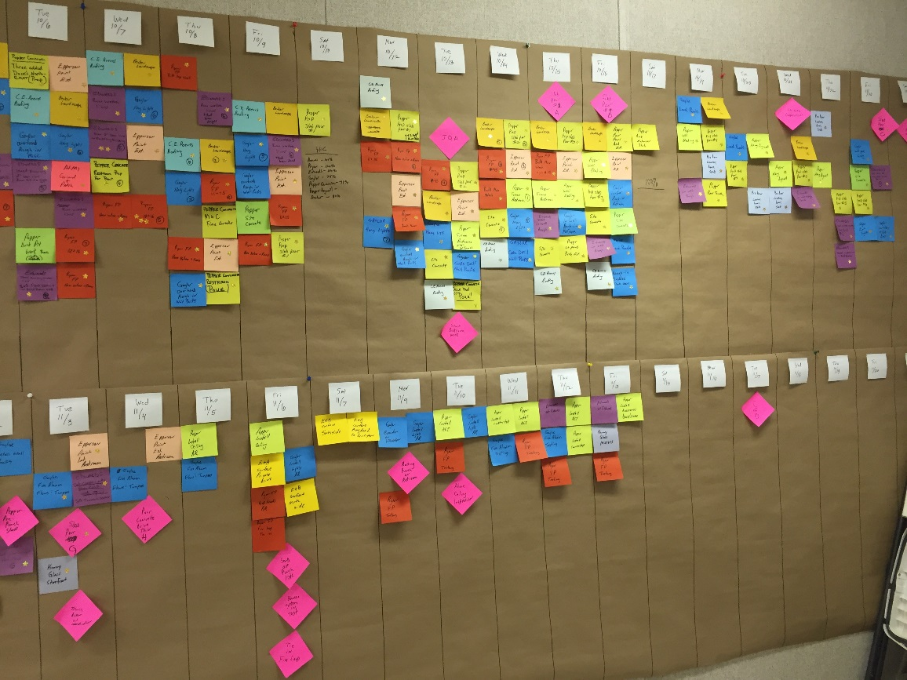
Structures Group
Project Manager: Gilberto Andrade
Team Members: Jackie Reyes / Miguel Rodriguez / Catherine Lopez / Harold Lucas

01.19.2017 Meeting
Milestone: By the end of this meeting you should understand and have presentation material showing:
- Identification of load bearing walls / columns (diagram the load path)
- Document required reinforcement
- Study foundation options for New Building addition (consider Chicago soil, what is the water table, anticipate loads)
Client Requests / Comments:
- I’m concerned about our schedule. What is our structural sequencing for the Old and New Buildings? Are we able to reinforce the existing church structure while excavating for the new building foundation at the same time?

------------------------------------------------------------------------------------------------------------------------------------------------------------

01.26-2017 Meeting
Milestone: By the end of this meeting you should understand and have presentation material showing:
  - 3 structural options for the New Building cantilever (Ex. Truss, Angle supports, Posts, etc.) Include their anticipated structural depths.
  - Basic structural grid for New Building including, dimensions in plan, structure material, floor-to-floor heights and depth of structure.
  - Structural strategy for Old Church renovation
Client Requests / Comments:
- How much extra structure is needed to put an elevator into the old church? Can this be done without affecting the integrity of the existing building?

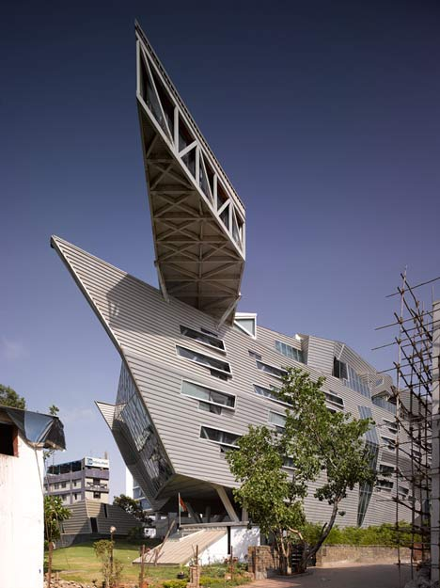
Old Building Group
Project Manager: Sara Kelly
Mentor Manager: Natalya Falk
Team Members: Uriel Gutierrez / Vlad Ayala / Deon Stephens

01.19.2017 Meeting
Milestone: By the end of this meeting you should understand and have presentation material showing:
- Floorplans of all primary use, and back-of-house (BOH) spaces from our programming sessions
- Coordinated access from St. Boniface church to new building and to landscaped site
- Square footages for each space which accurately reflect that program (*see Time Saver Standards for Building Types book*)
Client Requests / Comments:
- While this project is being re-purposed for a different use than originally intended, I’d like to have a permanent exhibit somewhere in the building that displays the history of the church, its architecture, and its place in the community.

------------------------------------------------------------------------------------------------------------------------------------------------------------

01.26-2017 Meeting
Milestone: By the end of this meeting you should understand and have presentation material showing:
  - Advancement of floor plans (make sure they’re coordinated with the other groups).
  - Two schematic-level building sections with coordinated structure and dimensioned room heights
  - Locate (on a plan or photo) all artistic components that you would like to preserve. (Stained glass, graffiti, painted ceilings, altar, etc.) Coordinate this information w/ construction group.
  - Find 5 precedent photos for your gallery aesthetic.
  - Find 5 items from the Stantec resource library as the basis for your materials palette.
Client Requests / Comments:
- I like where this current layout is going, but I’d really like to have a café somewhere in the church. I know we’re doing a restaurant on the top of the new building, but a café is a great casual way to engage with the community right off the street, AND it is a good idea to have a location nearby that can handle catering for any events held in the multi-purpose / gallery space.
- I’m not sure about locating the office in prime real estate on the ground floor. Can you put together a scheme where the offices are on the balcony level instead? I’d like to see both options.

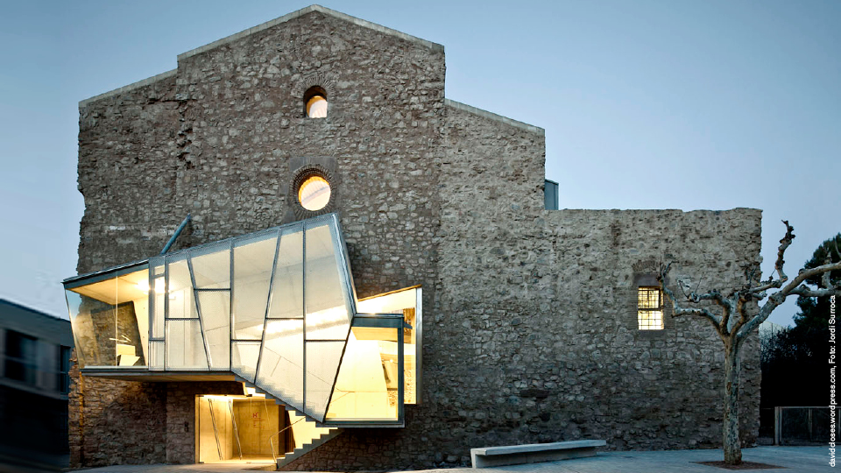
New Building Group
Project Manager: Will Manzanilla
Mentor Manager: Yao Lin
Team Members: Jose Miguel / Edilson Uribe / Antonio Perez

01.19.2017 Meeting
Milestone: By the end of this meeting you should understand and have presentation material showing:
- Floorplans of all primary use, and back-of-house (BOH) spaces from our programming sessions
- Coordinated access from your new building to St. Boniface church and to landscaped site
- Square footages for each space which accurately reflect that program (*see Time Saver Standards for Building Types book*)

Client Requests / Comments:
- Natural light is really important for the studio spaces, for the artists to work.
- What is the maximum height that I can build here per building code? How many floors do you think we provide and what floor-to-floor heights do you think would make for a comfortable studio space?

------------------------------------------------------------------------------------------------------------------------------------------------------------

01.26-2017 Meeting
Milestone: By the end of this meeting you should understand and have presentation material showing:
  - Advancement of floor plans (make sure they’re coordinated with the other groups).
  - Coordination with the structural group – make a final decision on structural grid, foundations, cantilever strategy, etc.
  - Find 5 precedent photos for your gallery aesthetic.
  - Find 5 items from the Stantec resource library as the basis for your materials palette.
Client Requests / Comments:
- By putting the restaurant on the top floor we end up with a security issue. This means that a restaurant patron must go through private studio space/floors to get to a public restaurant. I don’t want anyone to wander off the street to have access to any of the studios. There is a lot of expensive equipment in these studios and that makes me nervous. What types of program adjustments can you make to help maximize the security of this building?

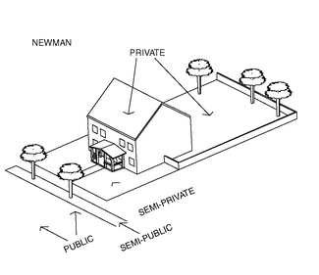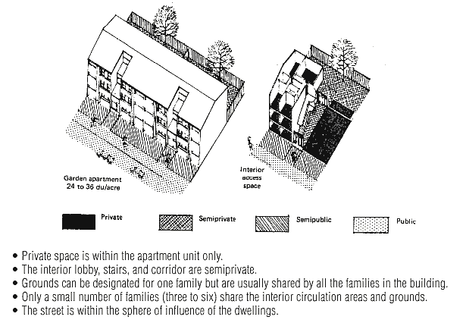

Site Group
Project Manager: Matthew Spivey
Mentor Manager: Josh Junge
Team Members: Tiauna Hill / Cameron Wilson / Mia Reyes

01.19.2017 Meeting
Milestone: By the end of this meeting you should understand and have presentation material showing:
- Site plan with square footages of all the types of parks that were included in the programming session.
- Coordinated access from the landscaped site to St. Boniface church and to new building
- Your team gets the final say on the rock wall.
- Layout for parking and loading zones.
- Plan for site visibility. Which views do you want to maximize or block? How engaged with the public is this space? What are the security measures of this property?

Client Requests / Comments:
- With so much parking in the area, we don’t need a huge parking lot. We do need in some capacity parking spots for 3 gallery/studio staff, 1 ADA spot, and 1 area reserved for loading and deliveries.

------------------------------------------------------------------------------------------------------------------------------------------------------------

01.26-2017 Meeting
Milestone: By the end of this meeting you should understand and have presentation material showing:
  - Finish milestone from last week!
Client Requests / Comments:
- Consider the security of the sculpture garden when designing access and location. How are you going to secure safety for children? Are people coming to see a paid exhibit? Is it open to the community or do you have to enter into the gallery first before visiting the park?

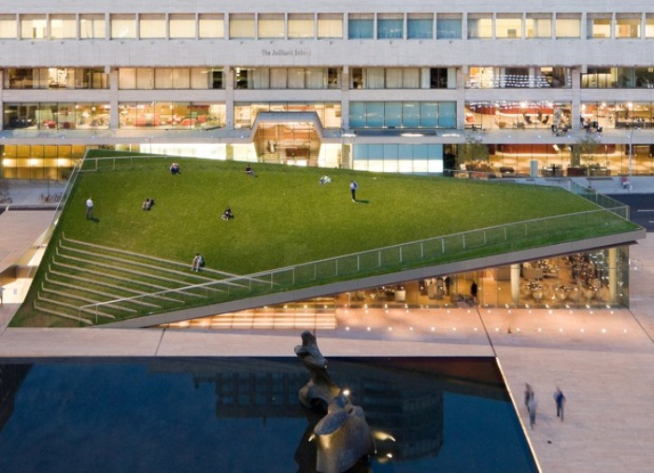

Structures Group
01.26-2017 Meeting
Milestone: By the end of this meeting you should understand and have presentation material showing:
  - 3 structural options for the New Building cantilever (Ex. Truss, Angle supports, Posts, etc.) Include their anticipated structural depths.
  - Basic structural grid for New Building including, dimensions in plan, structure material, floor-to-floor heights and depth of structure.
  - Structural strategy for Old Church renovation
Client Requests / Comments:
- How much extra structure is needed to put an elevator into the old church? Can this be done without affecting the integrity of the existing building?

New Building Group
01.19.2017 Meeting
Milestone: By the end of this meeting you should understand and have presentation material showing:
- Floorplans of all primary use, and back-of-house (BOH) spaces from our programming sessions
- Coordinated access from your new building to St. Boniface church and to landscaped site
- Square footages for each space which accurately reflect that program (*see Time Saver Standards for Building Types book*)

Client Requests / Comments:
- Natural light is really important for the studio spaces, for the artists to work.
- What is the maximum height that I can build here per building code? How many floors do you think we provide and what floor-to-floor heights do you think would make for a comfortable studio space?

------------------------------------------------------------------------------------------------------------------------------------------------------------

01.26-2017 Meeting
Milestone: By the end of this meeting you should understand and have presentation material showing:
  - Advancement of floor plans (make sure they’re coordinated with the other groups).
  - Coordination with the structural group – make a final decision on structural grid, foundations, cantilever strategy, etc.
  - Find 5 precedent photos for your gallery aesthetic.
  - Find 5 items from the Stantec resource library as the basis for your materials palette.
Client Requests / Comments:
- By putting the restaurant on the top floor we end up with a security issue. This means that a restaurant patron must go through private studio space/floors to get to a public restaurant. I don’t want anyone to wander off the street to have access to any of the studios. There is a lot of expensive equipment in these studios and that makes me nervous. What types of program adjustments can you make to help maximize the security of this building?

