Construction Group
Project Manager: Crushelle Triplett
Team Members: Jesse Mills / Jamie Kim / Leslie Sadkowski / Luis Cabrera

01.19.2017 Meeting
Milestone: By the end of this meeting you should understand and have presentation material showing:
- Identification of existing materials in St. Boniface Church
- Identification of location/quantity for material repairs / replacement
- Identification of building elements to be demolished due to poor / unstable condition
- Unit Costs of replacement materials / preliminary total cost for replacement materials

Client Requests / Comments:
- Compare costs for replacement of materials with traditional v. contemporary substitute alternatives. (Ex. Substitute cast stone for carved stone) Where can we save money?

------------------------------------------------------------------------------------------------------------------------------------------------------------
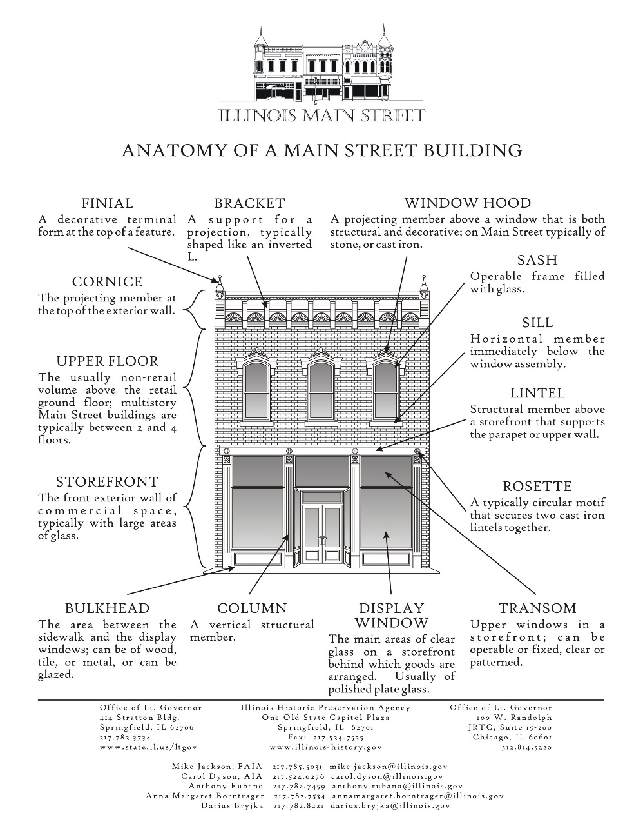

Structures Group
Project Manager: TBD
Team Members: Jackie Reyes / Gilberto Andrade / Miguel Rodriguez / Catherine Lopez

01.19.2017 Meeting
Milestone: By the end of this meeting you should understand and have presentation material showing:
- Identification of load bearing walls / columns (diagram the load path)
- Document required reinforcement
- Study foundation options for New Building addition (consider Chicago soil, what is the water table, anticipate loads)

Client Requests / Comments:
- I’m concerned about our schedule. What is our structural sequencing for the Old and New Buildings? Are we able to reinforce the existing church structure while excavating for the new building foundation at the same time?

------------------------------------------------------------------------------------------------------------------------------------------------------------

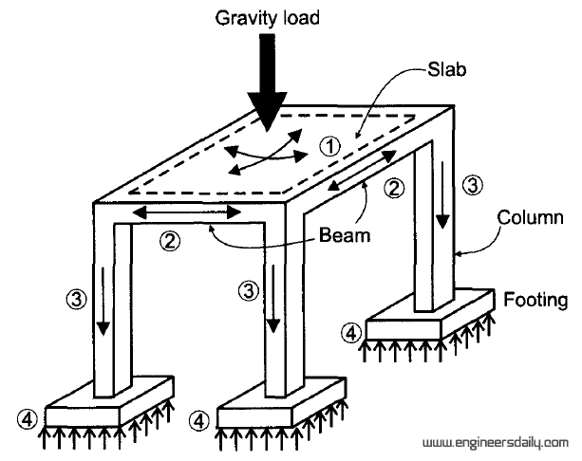

Old Building Group
Project Manager: TBD
Team Members: Sara Kelly / Uriel Gutierrez / Vlad Ayala / Deon Stephens

01.19.2017 Meeting
Milestone: By the end of this meeting you should understand and have presentation material showing:
- Floorplans of all primary use, and back-of-house (BOH) spaces from our programming sessions
- Coordinated access from St. Boniface church to new building and to landscaped site
- Square footages for each space which accurately reflect that program (*see Time Saver Standards for Building Types book*)

Client Requests / Comments:
- While this project is being re-purposed for a different use than originally intended, I’d like to have a permanent exhibit somewhere in the building that displays the history of the church, its architecture, and its place in the community.

------------------------------------------------------------------------------------------------------------------------------------------------------------

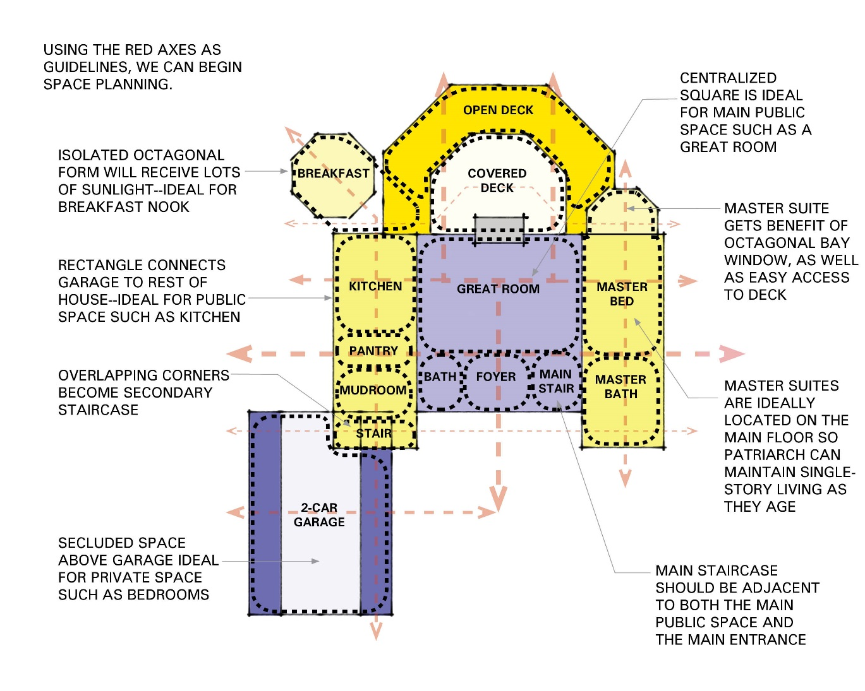

New Building Group
Project Manager: TBD
Team Members: Will Manzanilla / Jose Miguel / Edilson Uribe / Antonio Perez

01.19.2017 Meeting
Milestone: By the end of this meeting you should understand and have presentation material showing:
- Floorplans of all primary use, and back-of-house (BOH) spaces from our programming sessions
- Coordinated access from your new building to St. Boniface church and to landscaped site
- Square footages for each space which accurately reflect that program (*see Time Saver Standards for Building Types book*)

Client Requests / Comments:
- Natural light is really important for the studio spaces, for the artists to work.
- What is the maximum height that I can build here per building code? How many floors do you think we provide and what floor-to-floor heights do you think would make for a comfortable studio space?

------------------------------------------------------------------------------------------------------------------------------------------------------------

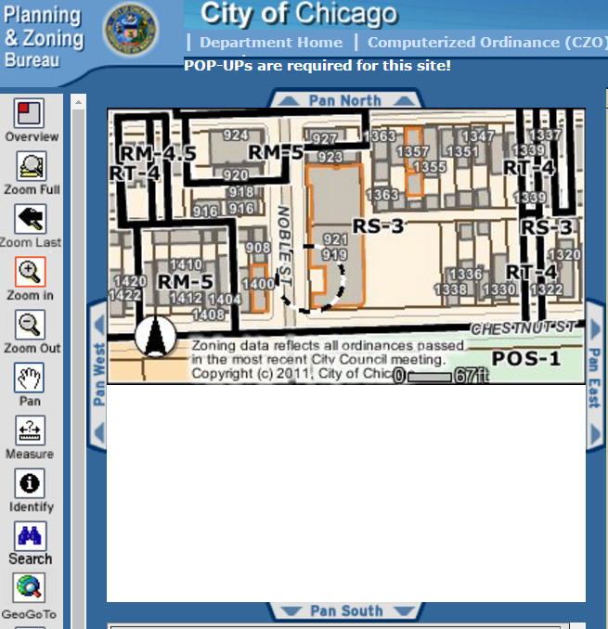

Site Group
Project Manager: TBD
Team Members: Tiauna Hill / Matthew Spivey / Cameron Wilson / Mia Reyes

01.19.2017 Meeting
Milestone: By the end of this meeting you should understand and have presentation material showing:
- Site plan with square footages of all the types of parks that were included in the programming session.
- Coordinated access from the landscaped site to St. Boniface church and to new building
- Your team gets the final say on the rock wall.
- Layout for parking and loading zones.
- Plan for site visibility. Which views do you want to maximize or block? How engaged with the public is this space? What are the security measures of this property?

Client Requests / Comments:
- With so much parking in the area, we don’t need a huge parking lot. We do need in some capacity parking spots for 3 gallery/studio staff, 1 ADA spot, and 1 area reserved for loading and deliveries.

------------------------------------------------------------------------------------------------------------------------------------------------------------

